|  |  |
| --- | --- |
| System Requirements Specifications Process | |
| Process Policy   * When complete requirements are not provided by the client the same will be elicited. * Gaps in requirement specified by the client identified against the SRS template are documented. * The SRS will be reviewed by the Stakeholders * The project will seek approval from the client, for SRS and changes to requirements * Traceability Matrix will be developed to track client specified requirements to deliverables. This will be updated with changes to requirements | |
| **All Rights Reserved**  This document is a property of Trianz. No part of this document may be copied or reproduced in any form or by any means, electronic, mechanical or otherwise without the prior written permission of Trianz. | |
| **Owner:** Nandini/Vinay/Aman | **RID: HTM**/5101/0207 |
| **Email: uccnandinisinha@gmail.com** | **Version:** 11.00 |
| **Date:** 07-Sept-2023 | **Total Pages:** 10 |
| **Distribution List:** All members of Chatty project | |
| 3rd Floor, Hulkul Brigade Centre  # 82, Lavelle Road  Bangalore – 560 001  Phone: +91-80-22127870  E-mail: contactus@trianz.com | |

**Table of Contents**

System Requirements Specifications Process 1

1 Introduction 3

1.1. Definitions/Acronyms/Abbreviations 3

1.2. Objectives 3

1.3. Scope 3

1.4. Roles and Responsibilities 3

1.5. Prerequisites 3

1.1.1 Resource 3

1.1.2 Training 4

1.6. References 4

2 Entry Criteria 4

3 Inputs 4

4 Process Flow 5

5 Process Description 6

1.7. Requirements Elicitation 6

1.8. Requirements Specification 7

1.9. Traceability Matrix 7

1.10. SRS Review and approval 7

1.11. Changes to SRS 7

6 Outputs 8

1.12. Deliverables 8

1.13. Quality Records 8

7 Exit Criteria 8

8 Process Assets 8

9 Measurement 8

10 Tailoring Guidelines 8

11 Standards Addressed 9

Appendix 10

Revision History 10

# Introduction

# CHATY is a social-networking tool that leverages technology advancement thereby allowing its users to communicate and share media. It offers a wonderful one-stop shopping experience for keeping in touch with people you know. It can be used for messaging, placing voice messages, making voice and video calls, share updates and photos, share locations, enhance local socializing in pidgin English, play games and make monetary financial transactions.

## Definitions/Acronyms/Abbreviations

|  |  |
| --- | --- |
| **Term** | **Description** |
| **SRS** | System Requirements Specification |
| **PM** | Project Manager |
| **SOW** | Statement of Work |
| **CCB** | Change Control Board |
| **QMG** | Quality Management Group |
| **RFP** | Request for Proposal |
| **CR** | Change Request |

## Objectives

CHATTY enormous social power will be let loosed as it will translate to become one of the main ways people will have to communicate in Nigeria and sub-Sahara Africa. Even when doing business, people will prefer CHATTY to email. With inbuilt plug ins that allow individuals to load pictures and videos and their contacts can make comments about them.

## Scope

One of the primary uses of CHATTY is messaging. Just like other social apps, you have a list of conversations that you’re engaged in. This feature is pivotal as you can add people in a variety of ways aside from the conventional way of details collection. When fully operational, you will be amazed how individuals will have to scan their phones during details collection.

## Roles and Responsibilities

|  |  |  |
| --- | --- | --- |
| **Role** | **Responsibility** | **Internal/External** |
| Project Manager | 1. Identify the stakeholders for the SRS 2. Form Requirements Gathering and Requirements Analysis teams and manage these activities/teams 3. Coordinate development and review of SRS internally and with the Client 4. Get Client approval of SRS 5. Manage changes to SRS | Internal |
| Requirements Elicitation Team | 1. Elicit and document Client requirements | Internal/External |
| Requirements Specification Team | 1. Analyze requirements provided by the Client and bridge the gaps 2. Prepare the SRS document 3. Get the SRS reviewed by the stakeholders as per the Review process | Internal/External |
| Stakeholders | 1. Review the SRS based on their role | Internal/External |
| Client | 1. Review and approve the SRS | External |

## Prerequisites

Resource

Requirements Elicitation Team:

* Past experience in requirements elicitation
* Knowledge of the project business domain

Requirements Specification Team:

* Knowledge and skill in requirements analysis
* Requirements documentation skills
* Awareness of the project business domain

Training

* Communication and Negotiation skills
* Documentation skills
* Business Domain
* On specific tools being used for requirements representation

## References

|  |  |
| --- | --- |
| **Document Number** | **Document Name** |
| HMT/5101/0206 | Project Management Planning Process |
| HMT/5101/0216 | Project Tracking process |
| HMT/ 5101/0211 | Review Process |

# 2.Entry Criteria

**Project Initiation**

* Feasibility study
* *Assigning project characters
* *Review
* *Project office location identification
* *Scheduling of project

1. Here are some more points
2. **Define the Project:** Start by defining the project's objectives and goals. Clearly state the purpose of the project and the things you hope to achieve.
3. **Understand the Project's Scope and Boundaries**: Identify the scope and boundaries by determining what is in and out of the scope.
4. **Stakeholder Engagement:** Before the planning phase begins, stakeholders should approve the project's objectives, scope, budget, and timeline.
5. **Conduct Feasibility Analysis:** This step involves assessing whether the project is feasible within the given constraints, such as time, budget, resources, and technology.
6. **Generate a Project Charte**r: A project charter captures key aspects of the project, including the project's objectives, scope, constraints, stakeholders, risks, budget, and timeline.
7. **Allocate Resources, Plan, Assess, and Manage Risks**: This step involves assessing potential risks and allocating the necessary resources to manage them.
8. **Establish Project Governance**: This means you have to define the roles and responsibilities of the project team and the project's governance structure.
9. **Form the Project Team:** Form a team of experts who will work together to deliver the project successfully.
10. **Communicate and Obtain Buy-In**: Communication is critical during the project initiation stage. Ensure that stakeholders and team members know what is expected of them.
11. **Kick-off the Project and Initial Planning**: Now that the project initiation phase is complete, you can kick off the project and begin initial planning, which involves developing detailed project plans, assigning tasks, and setting timelines

# Inputs

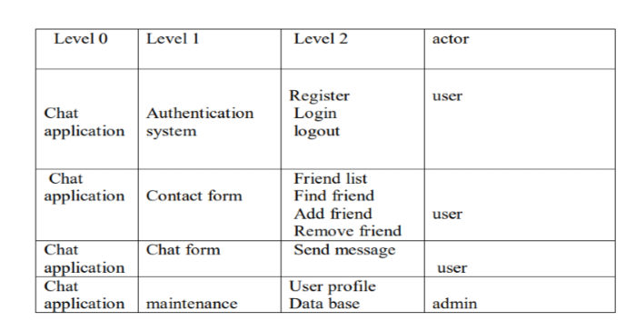

**Use-Case Diagram**

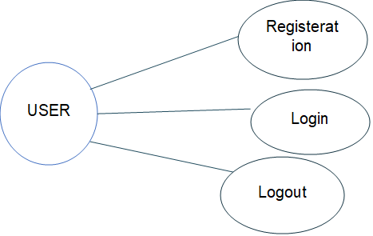  
  
  
**Input (Mind Map)**

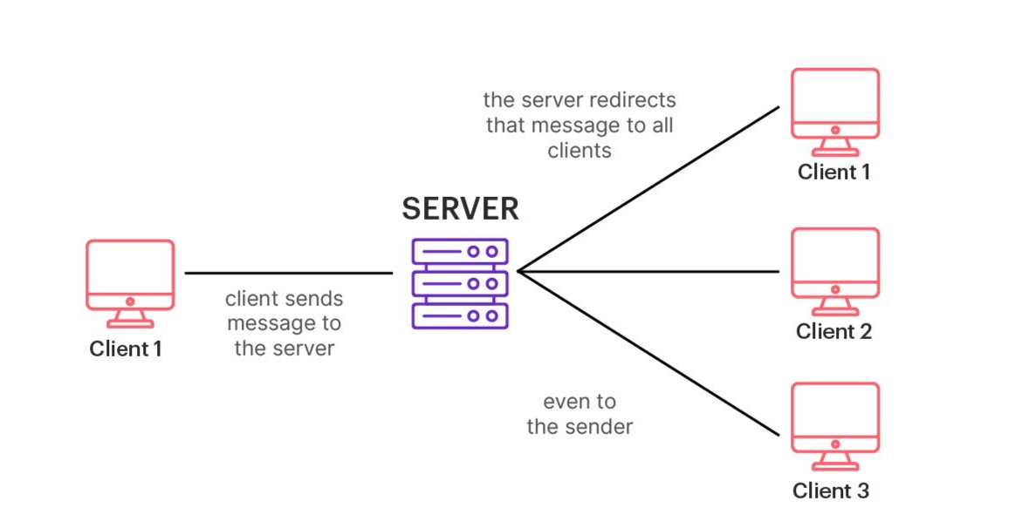

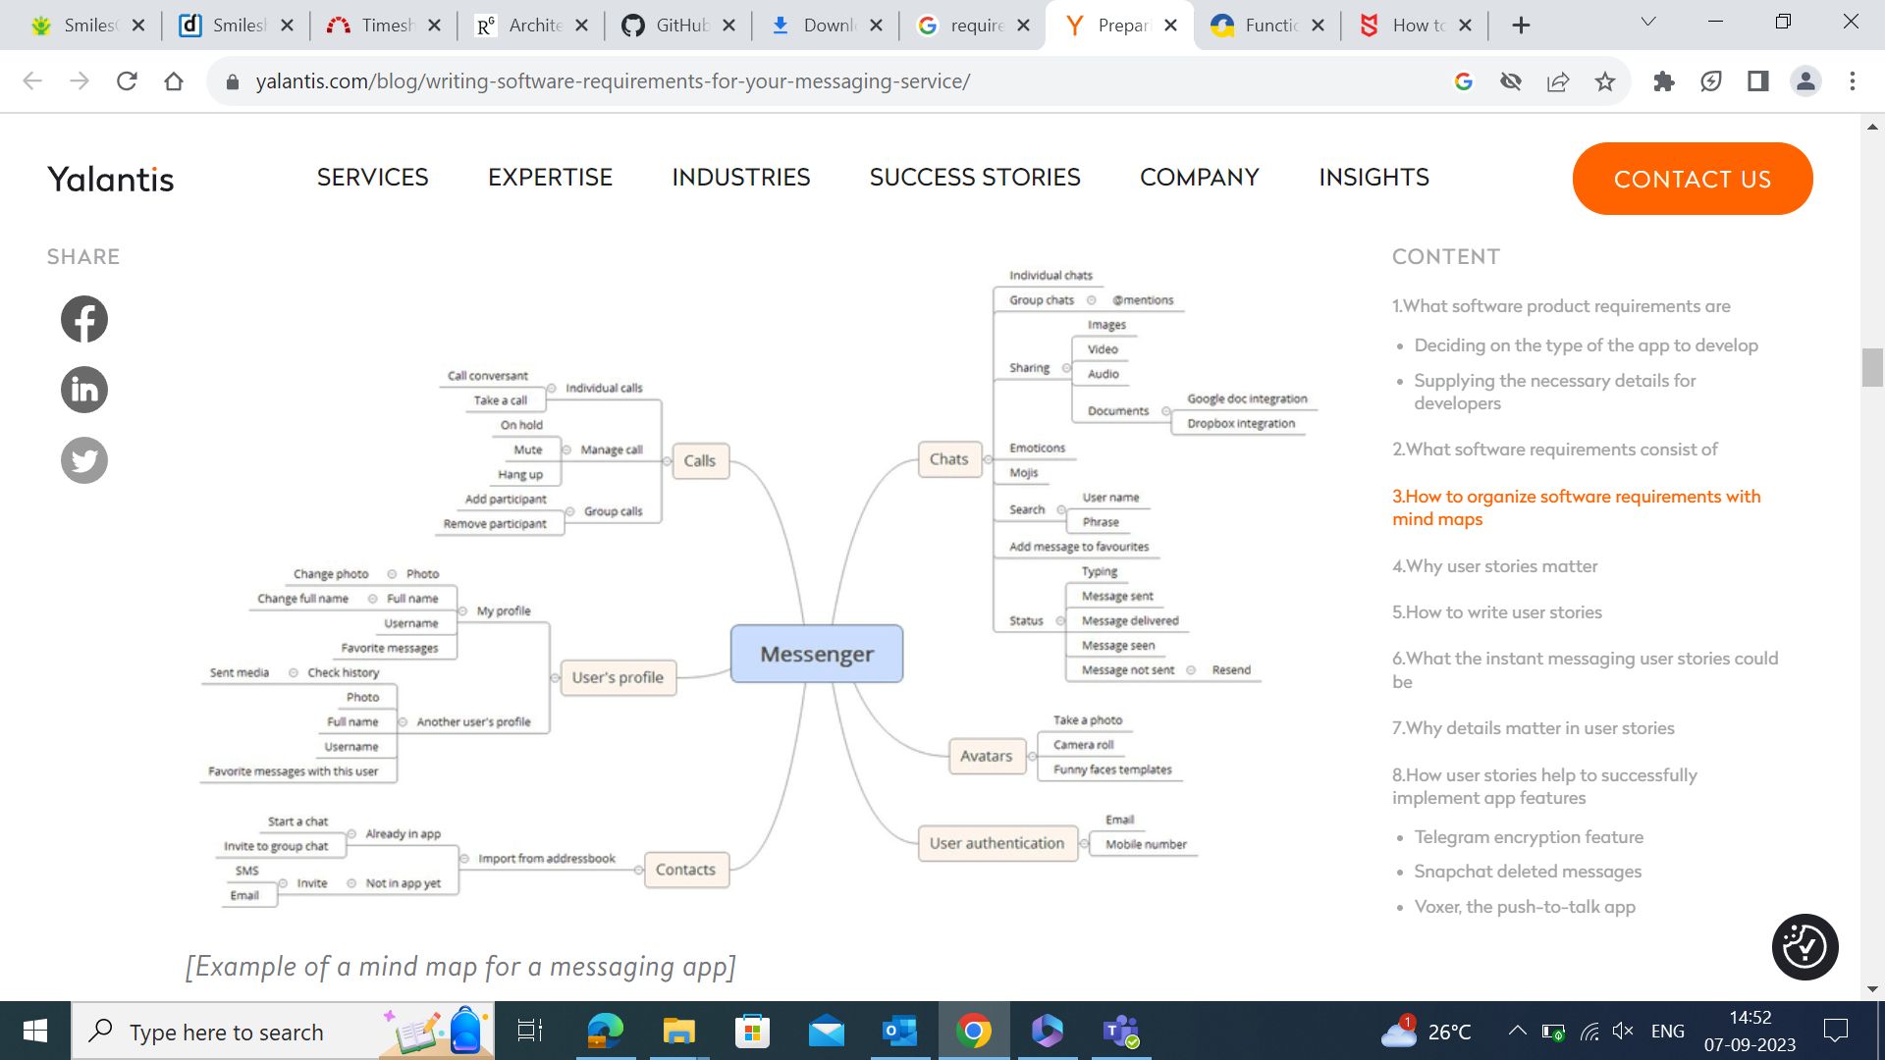

**3. Process Flow**

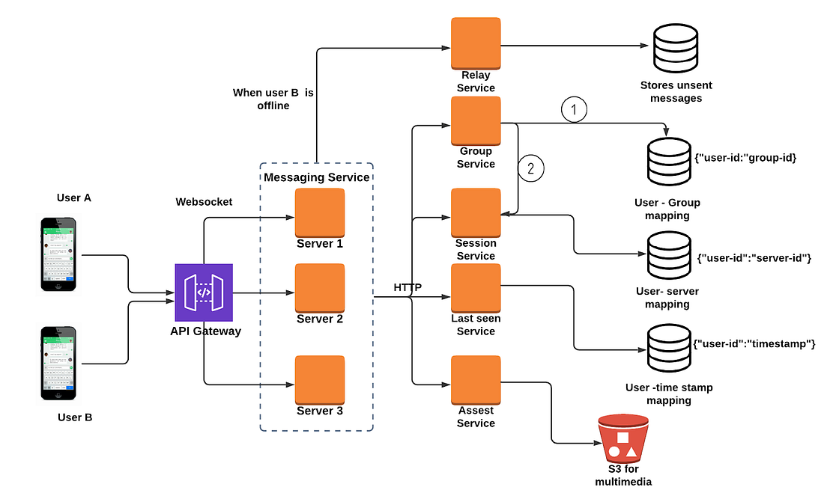

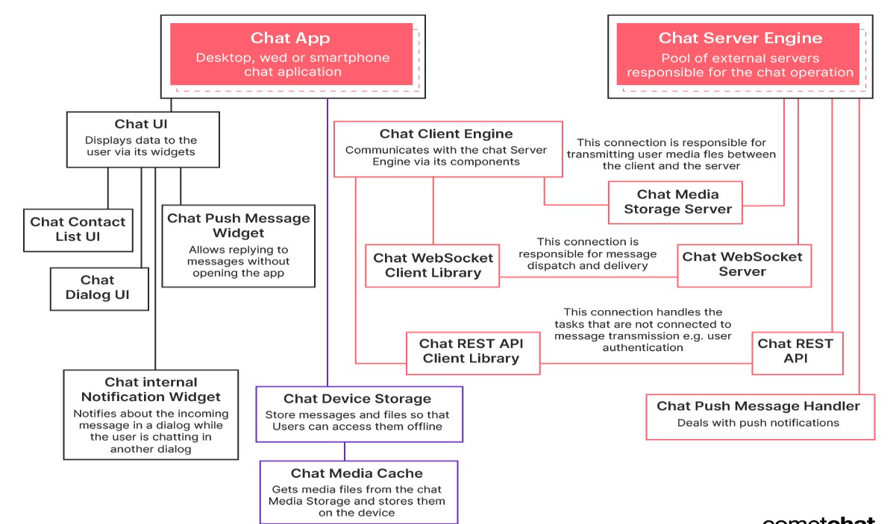

# Process Description

## Requirements Elicitation

**Hardware Interface**

Android phone 256 MB minimum RAM required Internet or LAN connections Processor with speed of 500MHz

**Tools and Technology**

Quality Planning -Software QFD

Product Innovation- Brainstorming, Mind-Map, TRIZ/ARIZ, Innovative algorithms

Software Analysis –Brainstorming, Mind-Map Design, patterns UML tools and technique

Database modelling tools- Mongo dB Compass, Mongoose, Mongo dB Driver

Software Development Methodology- Agile, scrum

Programming Language -Typescript, JavaScript, Dart, Json, yaml, swift, java

## Requirements Specification

* **Classify the requirements into various categories:**
* **Business Requirements** – Servers, Operating System
* **Use cases or scenarios-** Client1 and Client 2
* **Business rules** - messaging software for business is changing the way frontline employees communicate with each other. In non-desk industries, more and more companies are adopting instant messaging for business to consolidate internal communication and meet the needs of their workforce.
* **Functional requirements-** Users should be able to see the list of recent chats sorted by date.
* Users should be able to open a 1-on-1 chat, send and receive messages.
* Users should be able to add photo attachments to chat messages.
* Users should be able to see chat message status (sending, sent/failed, received) and read receipts.
* **Non-functional requirements-** Offline support (reading chat messages), Secure message storage and Real-time notifications.

**External Interface requirements-**

1. Video and voice attachments.
2. Sign-up and log-in.
3. Editing/Deleting messages.
4. Group chats.

* **Constraints-** Phishing is when you click on a link that redirects you to a malicious site that will steal or expose your confidential information. Scammers and hackers know that people communicating via IM or messaging apps are more likely to click on random links. They may not expect that a link will be fraudulent, unlike when they open an email.
* Bots are programs that pretend to be real-life users and send you spam, messages, advertisements, or attempt to link you to sales or phishing sites (outside the app). Other bots might suggest you play games or download additional apps.
* Getting your news solely through messaging may lead you to sites that publish false information. Some of these websites could be run by other countries or created just to spread fake news.
* Catfish would love to date you and whisk you off your feet! Romance scammers are con artists who pretend to be in love to get to the victim’s wallet.
* **Data Definitions-**

1 **Processes**

Installing the chatty on an android mobile device is as simple as installing the apk file.

2. **Registrations for new members**

To register a new user, Chatty app require the using to provide their email and phone number. It checks if the phone number or email already has a user in the database, if it doesn’t the user is then taken to a screen where they fill in their details which include full name, date of birth and a short description of themselves. The user is then asked to confirm their email and phone number through the email message or SMS sent to them which contains a verification code link to their account. Finally, the user goes through it local biometric lock and adds their profile picture if need be, then done. The user will now have a full active account.

**3. Login Features**

Chatty uses a two-factor login system which includes biometric authentication and email or phone number verification. First the phone number is verified to belong to a user and then a verification code is sent to both the users’ email and phone number if the phone number was found to belong to a user. Next the user is asking to continue with the login process with the device local biometric authentication, which could be either face id or fingerprint authentication.

**4. Adding Friends**

Adding friends through the chatty app can be done by clicking floating button at the bottom right corner of the app which after giving the app permission brings a list of all your contact list saved on your mobile phone.

**5. Chat Form**

The Chat Form hold and displays the current conversation going on between two users of the app, this conversation is not saved locally or on a live server, so a new session is created for every new instance in time. The chat form has two main items which are the message areas which on-going conversations can be seen and the chat form which carry an input field to send new messages area.

**6. Account Settings**

Using the Account settings is very simple and clear, as there are not too many functions on it. The Account settings allows you to logout, see your contact list count, view your details and open the app settings and app info.

* **Deployment Scenarios-**

For further details refer to Requirements Elicitation Guidelines.

* If a prototype is required, the team develops the same as part of this phase
* The PM then assigns an author to prepare the SRS document for the project
* The author may call for a meeting with the team members and concerned personnel (with domain knowledge) for discussion on the contents of the SRS
* At the discretion of the PM, the Client may also be invited to join these meetings
* The author then prepares the System Requirement Specification document using Systems Requirements Specification template for the project, and addresses all sections pertinent to the project.

## Traceability Matrix

* Requirements specification team develops the Traceability matrix. Refer to Traceability Matrix template
* Traceability matrix is created as per the Traceability Matrix guidelines

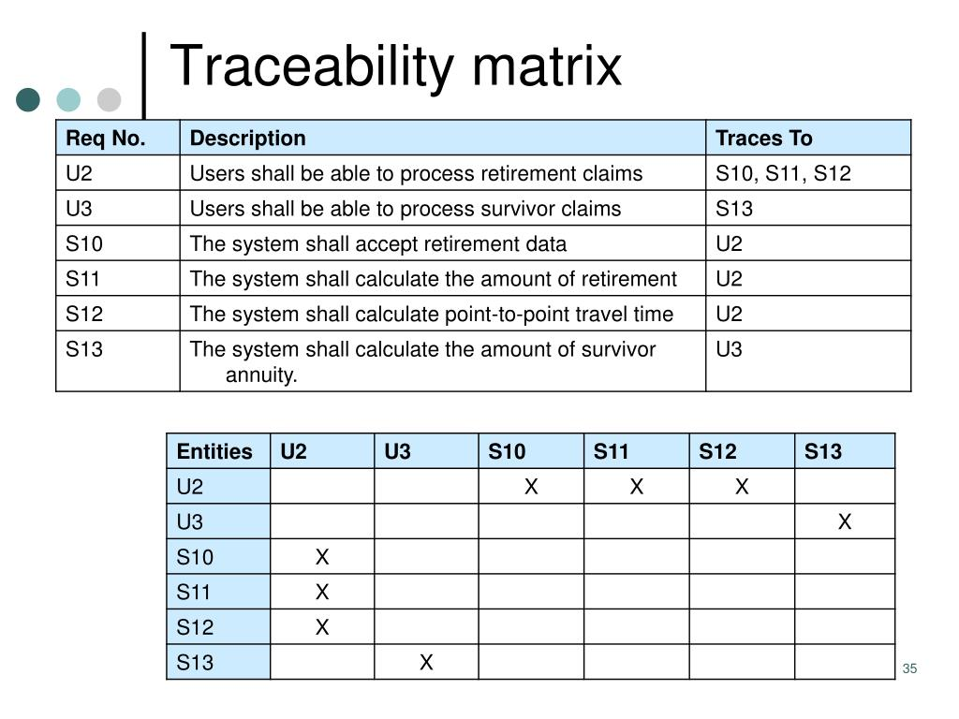

## SRS Review and approval

* The author coordinates for a formal review of the SRS Document as per the Review Process and SRS Review Check List
* PM makes sure SRS is reviewed and approved by the client. Refer to Review process for details on conducting reviews

## Changes to SRS

* Whenever the Client requests changes to the requirements, the PM verifies the impact of the change
* The PM then may call for a CCB meeting
* The CCB reviews the changes along with the impact of the change on the effort, schedule and cost. Refer to Project Management Planning process and Project Tracking process for details on how to constitute CCB, how to log in, track and resolve Change Requests
* In case of major changes, changes that have an impact on the effort, cost, or milestone, Client approval is obtained before the changes are incorporated
* At the discretion of the PM, any minor internal changes identified to the requirements may be sent to the Client for a re-approval or baselined without Client approval
* PM verifies whether the approved CRs have any impact on the project objectives and the planning parameters. Under such circumstances PM initiates re-planning. Refer to Project Tracking process for details.

# Outputs

## Deliverables

* Approved System Requirements Specification document
* Notes and minutes from requirements elicitation
* Prototype, if available
* Change Log
* Traceability Matrix

## Quality Records

|  |  |
| --- | --- |
| **Quality Record** | **Responsibility** |
| SRS Review Report | PM |
| Approval of SRS by the client | PM |
| Change request approval | PM |

# Exit Criteria

* Project Closure

# Process Assets

|  |  |
| --- | --- |
| **Document Number** | **Document Name** |
| QMS/5101/0142 | Systems Requirements Specification Template |
| QMS/5101/0290 | Requirements Elicitation Guideline |
| QMS/5101/0054 | SRS Review Checklist |
| QMS/5101/0193 | Traceability Matrix |

# Measurement

* Defects found in a baselined SRS (Number of defects that can be traced to initial set of baselined requirements)
* Requirement Volatility (Number of changes received and Number of changes implemented, phase wise)

# Tailoring Guidelines

|  |  |  |
| --- | --- | --- |
| **Process Step** | **Tailoring provided** | **Remarks** |
| Review of SRS by relevant stake holders before baseline of SRS | PM, may involve Client to reduce iteration of the SRS document |  |
| Updation of SRS while addressing CRs | The frequency of updation may be identified in the PMP if the changes are too many. | However updating SRS is mandatory at every phase completion |
| Creation and maintenance of SRS as an independent artifact | SRS may be combined with the design document, In case of small projects, |  |
| Absorption of changes without additional cost to the Client | Project Manager may define the maximum extent to which the additional costs due to changes may be absorbed by the project without an additional cost to the Client, with the approval of Director Delivery | All changes should be tracked to closure through the change log. |

# Standards Addressed

|  |  |  |
| --- | --- | --- |
| **ISO 9001:2000** | | |
| **Clause** | | **Description** |
| 7.2.1 | | Determination of requirements related to the project |
| **CMMI** | | |
| **Process Area** | **Specific Practice** | **Description** |
| Requirements Management | SP 1.1 | Obtain an Understanding of Requirements |
|  | SP 1.2 | Obtain Commitment to Requirements |
|  | SP 1.3 | Manage Requirements Changes |
|  | SP 1.3 | Maintain Bidirectional Traceability of Requirements |
|  | SP 1.4 | Identify Inconsistencies between Project Work and Requirements |
| Requirements Development | SP 1.1 | Elicit Needs |
|  | SP 1.2 | Develop the Client Requirements |
|  | SP 2.1 | Establish Product and Product-Component Requirements |
|  | SP 2.2 | Allocate Product-Component Requirements |
|  | SP 2.3 | Identify Interface Requirements |
|  | SP 3.1 | Establish Operational Concepts and Scenarios |
|  | SP 3.2 | Establish a Definition of Required Functionality |
|  | SP 3.3 | Analyze Requirements |
|  | SP 3.4 | Analyze Requirements to Achieve Balance |
|  | SP 3.5 | Validate Requirements with Comprehensive Methods |

# Appendix

None

# Revision History

|  |  |  |  |  |
| --- | --- | --- | --- | --- |
| **Rev. No.** | **Author** | **Date** | **Reason for Change** | **Change Description** |
| 1.00 | Vandana M | 20 Sep ‘97 | None | None |
| 7.01 | Anandi | 09 Oct 02 | Updation to 2000 standards | * Section 8 on Standards Addressed to reflect the clauses applicable to 2000 standards * General formatting changes |
| 8.00 | Anandi | 25 Oct 02 | Approval by Vandana M | * Baselined to version 8.00 |
| 8.01 | Vivek | 17 Dec 04 | Merger with Trianz | * Changed EximSoft name to Trianz |
| 9.00 | Anandi | 22 Dec 04 | Review for baseline | * Approval for baseline |
| 10.00 | Bala | 26 Oct 05 | Approved for baseline addressing CMMI Gaps | * Process policies modified * Under process Description, "Requirements Elicitation process" added as a section * Requirement analysis process modified * The entire document is aligned to new process template |
| 10.01 | Anandi | 04-Apr-06 | Review by QMG | * Addition to Measurement and Tailoring guidelines |
| 11.00 | Balu Nair | 21-Apr-06 | Approved by Bala Raja | * Baselined |